

**STUDENT INDUSTRIAL WORK EXPERIENCE SCHEME**

**(JANUARY 2019 – JUNE 2019)**

**AT**

**CHEVRON NIGERIA LIMITED (CNL)**



**BY**

**NAME OF STUDENT: TAMUNOIBI MIEBAKA-OGAN**

**(MATRIC NO: 16CG021429)**

**SUBMITTED TO**

**THE DEPARTMENT OF COMPUTER AND INFORMATION SCIENCES,**

**COLLEGE OF SCIENCE AND TECHNOLOGY,**

**COVENANT UNIVERSITY**

***IN PARTIAL FULFILMENT FOR THE AWARD OF THE DEGREE OF BACHELOR OF SCIENCE (B.SC.), COMPUTER SCIENCE,***

**COVENANT UNIVERSITY, OTA, OGUN STATE, NIGERIA**

**SEPTEMBER, 2019**

## DEDICATION

I dedicate this report firstly to God, I am grateful because he has given me purpose as well as the discipline to put this report together.

This work is also dedicated to my mom; she is a massive part of my life. Finally, I dedicate this report to everyone that provided mentorship to me at Chevron Nigeria Limited during my internship.

## ACKNOWLEDGEMENTS

I am grateful to have had this opportunity given by my Department (Computer and Information Sciences) to be enrolled in the SIWES scheme. I appreciate the Capital Projects Information Management Support Team members at Chevron Nigeria Limited for a plethora of work opportunity and level of trust given to me.

I would also like to thank Elizabeth Adegbaju, Zainab Alayinde, Daniel Eremonsele and many others, fellow interns at the time from whom I also learnt a lot.

## ABSTRACT

A Summary of my Student Industrial Work Experience Scheme (SIWES) which was undertaken at Chevron Nigeria Limited, Lagos, which commenced on the 14th of January 2019 and ended on the 30th of June, 2019, in partial fulfilment of the requirement of a Bachelor of Science (B.sc) in Computer Science. This report contains some information about the company of engagement, the description of the roles I took on, my participation and tasks done, challenges encountered, my observation of the entire experience and conclusion.

The SIWES program is a skills training program designed to expose and prepare students of Universities and also other tertiary institutions for the Industrial work situation they are likely to meet after graduation; the main aim and objective of this program is to adequately foster the knowledge of what a student learnt in school in relation to what is happening in real world. This Report is simply my unique experience and lessons learnt from my SIWES training.

## TABLE OF CONTENT

**DEDICATION2**

**ACKNOWLEDGEMENTS3**

**ABSTRACT4**

**TABLE OF CONTENTS5**

**LIST OF FIGURES6**

**LIST OF TABLES6**

**CHAPTER ONE7**

1.1 Collection of SIWES letter of placement7

1.2 Information About Chevron Nigeria Limited 9

1.3 Submission Of Vital Documents12

1.4 Internship Experience 12

**CHAPTER TWO13**

2.1 Facilities/Tools 13

2.2 Quality of Supervision 23

2.3 Work Done & Knowledge Gained 26

**CHAPTER THREE37**

3.1.1 Application Of Gained Knowledge On My Field And Educational Career37

3.1.2 Application Of Gained Knowledge On Goals Of Company Of Engagement 37

3.1.3 Application Of Gained Knowledge To The Larger Society38

3.1.4 Corroboration Of Practical Knowledge With Theoretical Knowledge Learnt On Campus38

3.1.5 Work Done & Knowledge Gained38

3.2.1 CHALLENGES FACED BY STUDENT39

3.2.2 CHALLENGES FACED BY COMPANY39

3.2.3 PROJECT IDENTIFIED BY STUDENT39

**CHAPTER FOUR40**

CONCLUSION40

## LIST OF FIGURES

list of figures

Figure 1: My SIWES letter 7

Figure 2: My Acceptance Letter 8

Figure 3: Hierarchy Of Chevron Departments (Ogarnogram). 11

Figure 4: Shows a Microsoft Form 13

Figure 5: Shows the Interface of Microsoft Power BI 15

Figure 6: Shows the Interface of UIPath 16

Figure 7: Shows Recieved Certificate on Completion of SharePoint Training 17

Figure 8: Shows a SharePoint Page 17

Figure 9: Services provided by eB Information Manager 18

Figure 10: Shows an eB Information Manager Interface 19

Figure 11: Shows a Microsoft Excel Interface 20

Figure 12: Shows a Microsoft Teams Interface 21

Figure 13: A Degaussing Device 22

Figure 14: My Internship WorkPlan (Page 1 of 3) 24

Figure 15: My Internship WorkPlan (Page 2 of 3) 25

Figure 16: My Internship WorkPlan (Page 3 of 3) 26

Figure 17: Design of Agbami Operations Team Page (Page 1 of 2). 30

Figure 18: Design of Agbami Operations Team Page (Page 2 of 2). 30

Figure 19: My Completed Trainings 32

Figure 20: Data Privacy Training Certificate 33

Figure 21: Information Risk Management Training Certificate. 33

Figure 22: Uniform Resource Locator Training Certificate 34

Figure 23: Email Security Training Certificate 34

Figure 24: Data Management Training Certificate 35

Figure 25: Upstream Literacy Training Certificate 35

Figure 26: Business Conduct & Ethics Code Training Certificate 36

## CHAPTER ONE: INTRODUCTION

### Collection of SIWES letter of placement

I attended a seminar on the rudiments of SIWES training procedures held Covenant University as a prerequisite for all students proceeding on SIWES training after which I received my SIWES letter of placement from my Department

I sent out application letters along with my SIWES letter to various companies such as Hotels.com.ng, Quidax, Chevron Nigeria Limited requesting for internship opportunity. Quidax responded to acknowledge the receipt of my application but mentioned that they had already received the pool of applications they wanted. I got a positive response from Hotels.com.ng to proceed to a screening Phase but I had already been accepted by Chevron then and decided to serve at Chevron.

I was invited by Chevron Nigeria Limited to sit for an Aptitude test which in which I was successful and proceeded to take a medical test before receiving my acceptance letter from Chevron. I resumed at Chevron Nigeria Limited on the 14th of January 2019. Below is view of my SIWES Letter.

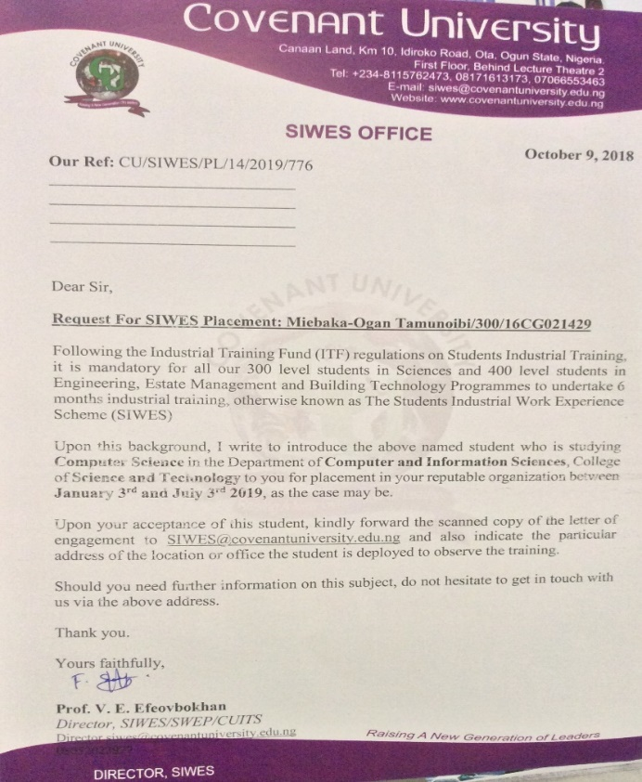

**FIG 1: My SIWES letter**

Here is a Picture of my acceptance Letter which I received from Chevron Nigeria Limited.

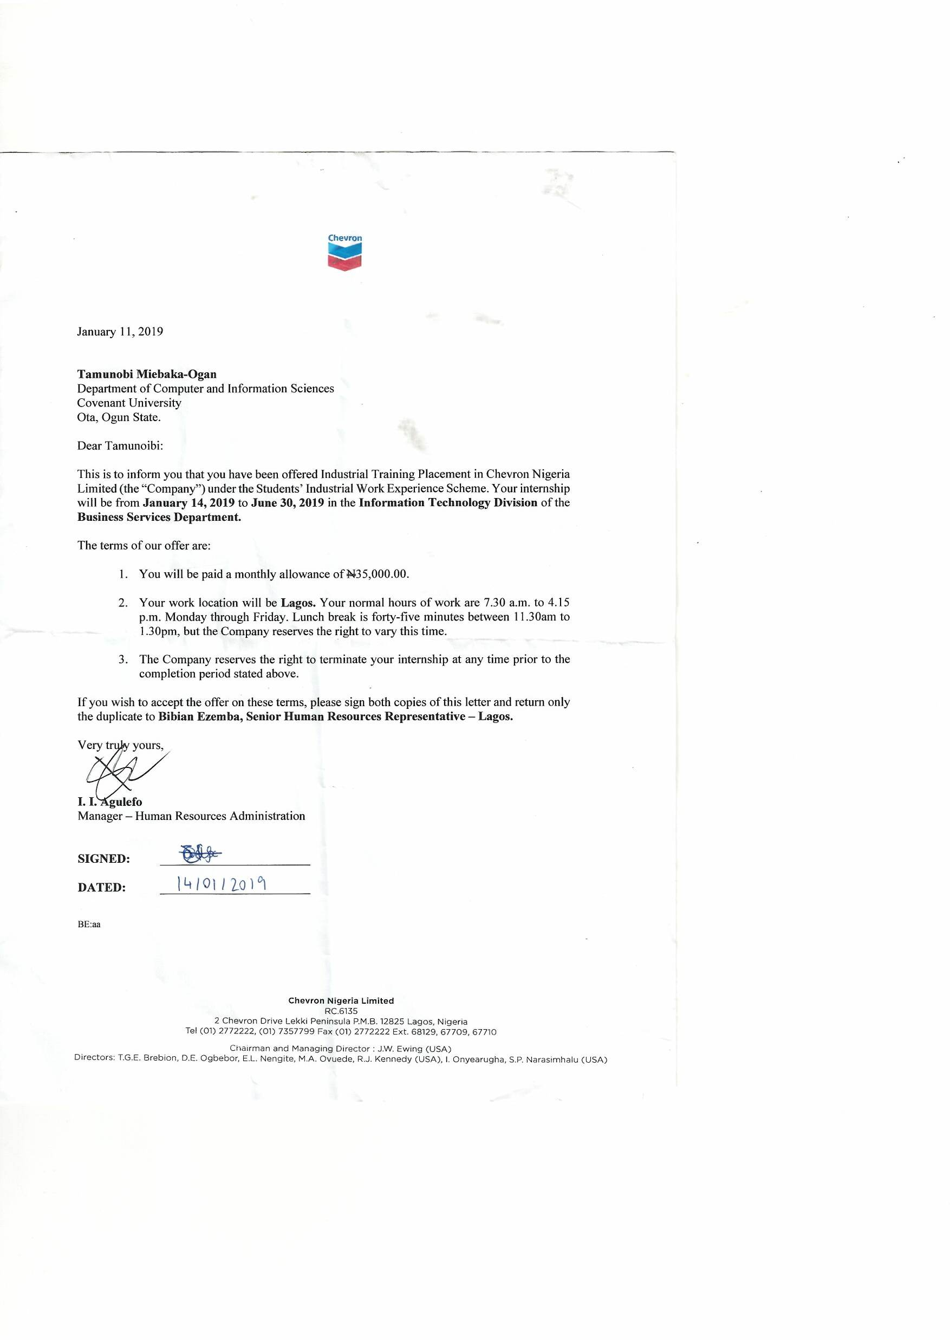

**Fig 2: My Acceptance Letter**

### 1.2. Information About Chevron Nigeria Limited

Chevron Nigeria Limited is an Oil, Gas & Energy Company. Chevron is the second largest integrated energy company in the world. With a diverse and highly skilled global workforce approximately 61,500 employees and around 3,300 service station employees under Chevron Corporation. Around the world, Chevron produces 2.622 mill net oil- equivalent barrels per day and approximately 73 percent of it outside USA in around 20 different countries.

Chevron Nigeria Limited is a subsidiary of [Chevron Corporation](https://en.wikipedia.org/wiki/Chevron_Corporation) and it is one of the largest oil producers in Nigeria. It was previously operating in Nigeria under the business name of [Gulf Oil](https://en.wikipedia.org/wiki/Gulf_Oil) Company until merger activities changed its name to Chevron Nigeria. After another merger by the parent company with Texaco, the Nigerian oil and gas assets of Texaco Overseas Petroleum Company of Nigeria were merged into Chevron. In Nigeria, Chevron operates under a joint-venture arrangement with the Nigerian National Petroleum Corporation (NNPC) for the onshore and offshore assets in the Niger Delta region.

Chevron also has extensive interests in multi-partner Deepwater operations. Chevron operates the Agbami Field, one of Nigeria’s largest Deepwater discoveries. In 2017, Chevron’s net daily production in Nigeria averaged 207,000 barrels of crude oil, 223 million cubic feet of natural gas and 6,000 barrels of liquefied petroleum gas (LPG). Chevron operates the Agbami Field, which lies 70 miles (113 km) off the coast of the central Niger Delta region and spans 45,000 acres (182 sq. km). Discovered in 1998, the Agbami Field is at a water depth of approximately 4,800 feet (1,463 m). Chevron has a 67.3 percent interest in the field. In 2017, net daily production averaged 119,000 barrels of crude oil and 12 million cubic feet of natural gas.

Chevron is involved in natural gas projects in the western Niger Delta and Escravos areas, including the Escravos Gas Plant (EGP), the Escravos Gas-to-Liquids (EGTL) facility and the Sonam Field Development Project. CNL operates the EGP, which has a total capacity of 680 million cubic feet per day of natural gas and LPG and a condensate export capacity of 58,000 barrels per day. Chevron and the NNPC also operate the EGTL facility, a 33,000-barrel-per-day gas-to-liquids plant.

Chevron Nigeria Limited’s Organisational Culture

Chevron believes in **Operational Excellence (OE),** a framework they have extended that supports culture of safety, environmental stewardship and top performance. Chevron believes that accidents are preventable and they have policies, devices, tools and behavioural expectations in place to assist in achieving that goal through their workforce. Chevron's OE safety culture is based on Ten (10) Tenets of Operation, a code of conduct that employees and contractors use and one that supervisors and managers reinforce.

The tenets are based on two key principles:

* Do it safely or not at all.
* There is always time to do it right.

In addition, the tenets call for always involving the right people, those most knowledgeable, experienced or familiar with decisions affecting safety procedures and equipment.

These tenets are:

* Always operate within design and environmental limits.
* Always operate in a safe and controlled condition.
* Always ensure safety devices are in place and functioning.
* Always follow safe work practices and procedures.
* Always meet or exceed customers’ requirements.
* Always maintain integrity of dedicated systems.
* Always comply with all applicable rules and regulations.
* Always address abnormal conditions.
* Always follow written procedures for high-risk or unusual situations.
* Always involve the right people in decisions that affect procedures and equipment.

**Internship Policy**

Every intern:

* Must write an entrance exam consisting of Math, English and Abstract.
* Take a medical test at the Gbagada branch and pass before being hired.
* Has a privilege to use the medical clinic for free.
* Has free lunch provided at the cafeteria.
* Can join the Staff bus to and from Work.
* Interns must make a presentation to the Unit Leadership Team at least once every 3months and make a final presentation in the month of Internship Conclusion.

**Products and Services**

While working at Chevron, I learned of the different products and services that they have to offer to the world which are:

* Oil
* Gas
* Energy
* Community Projects

**FIG 3: Hierarchy Of Chevron Departments (Ogarnogram).**

### 1.3. Submission of Vital Documents

I submitted my letter of acceptance through an email to the SIWES supervisor in Covenant University. After about three (3) weeks I was also able to locate the ITF nearest to my company of engagement to submit the Students Commencement of Attachment Form (SCAF) form.

### 1.4. Internship Experience:

I began my internship at Chevron Nigeria Limited on the 14th of January 2019, resumed at 7:30am was led to the HR Building in the premises to have an Orientation/Onboarding on the Chevron Work Environment. From the orientation session a could deduct that at the core of all chevron ideology and procedure was the culture of Safety. We were thought to identify hazards in the work place, when to take action ourselves and when, as well as whom to escalate the matter to if such hazard is beyond our job description.

After the HR onboarding I was assigned to the Information Technology (IT) division of Chevron Nigeria. The Information Technology division as popularly said in chevron has the objective of using technology to convert “hard work” to “smart work”. The Information Technology division leverages on current technology to enhance/optimize Business procedures thereby giving Chevron Nigeria a competitive advantage among its competitors.

I was assigned to the Information Management department within the information Technology Division. Within this department I worked with the Major Capital Projects Information Management Support (MCPIMS) team. Later on I also spent 2weeks with the Information Management Operations Unit, 2weeks with the Information Management Business Services Unit and 1week with the Data Science Unit before concluding my internship in my starting Unit.

# CHAPTER TWO: FACILITIES AVAILABLE

### Facilities/Tools

Working at Chevron Nigeria Limited with the Information Management Team, I had the opportunity of accessing different facilities to gain knowledge about their theoretical background and the company’s specific method of application. As a Student of Computer Science, most of the facilities I worked with were software resources used to aid the information management process. So I share more about this below:

**Microsoft Forms**

Microsoft Forms (formerly Office Forms) is an [online survey creator](https://en.wikipedia.org/wiki/Survey_data_collection#Online_surveys), part of [Office 365](https://en.wikipedia.org/wiki/Office_365). Released by [Microsoft](https://en.wikipedia.org/wiki/Microsoft) in June 2016, Forms allows educators to create surveys and quizzes with automatic marking. The data can be exported to [Microsoft Excel](https://en.wikipedia.org/wiki/Microsoft_Excel).

During my internship I made use of this software several times, one of which was to create a form to digitally capture attendance during the NMA IT Digital Expo in February 2019 using Barcode Scanners Applications on mobile devices to automatically direct users to a webpage to collate Attendance. Another use case was a survey I created to get feedback from the Major Capital Projects Information Management Support (MCPIM) Team on the standard work process in order to create a uniform workflow across the team.

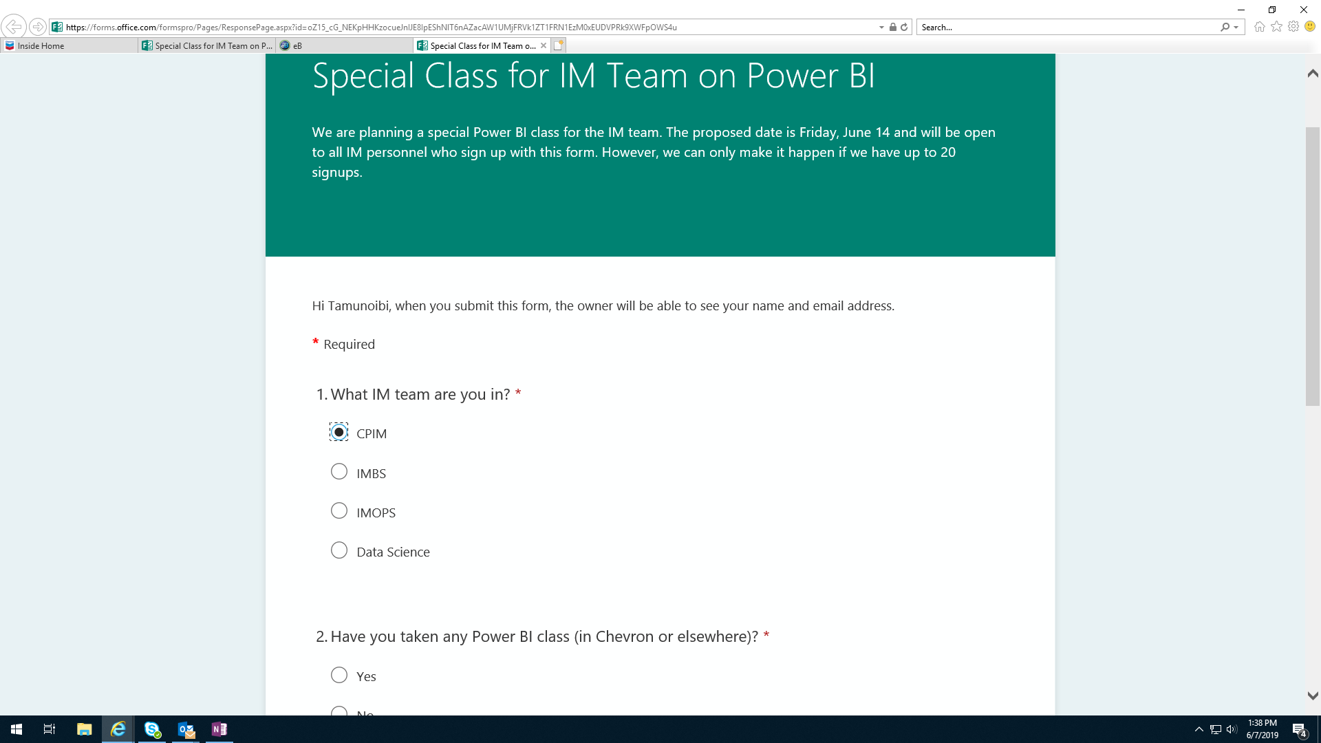

**FIG 4: Shows a Microsoft Form.**

**Microsoft Power BI**

Power BI is a [business analytics](https://en.wikipedia.org/wiki/Business_analytics) service by [Microsoft](https://en.wikipedia.org/wiki/Microsoft). It aims to provide interactive [visualizations](https://en.wikipedia.org/wiki/Data_visualization) and [business intelligence](https://en.wikipedia.org/wiki/Business_intelligence) capabilities with an interface simple enough for end users to create their own reports and dashboards. Key components of the Power BI ecosystem comprises:

**Power BI Desktop**

The Windows-desktop-based application for PCs and desktops, primarily for designing and publishing reports to the Service.

**Power BI Service**

The SaaS (software as a service) based online service formerly known as Power BI for Office 365, now referred to as PowerBI.com or simply Power BI.

**Power BI Mobile Apps**

The Power BI Mobile apps for Android and iOS devices, as well as for Windows phones and tablets.

**Power BI Gateway**

Gateways used to sync external data in and out of Power BI. In Enterprise mode, can also be used by Flows and PowerApps in Office 365.

**Power BI Embedded**

Power BI [REST API](https://en.wikipedia.org/wiki/REST_API) can be used to build dashboards and reports into the custom applications that serves Power BI users, as well as non-Power BI users.

**Power BI Report Server**

An On-Premises Power BI Reporting solution for companies that won't or can't store data in the cloud-based Power BI Service.

**Power BI Visuals Marketplace**

A marketplace of custom visuals and R-powered visuals.

During my internship at chevron I attended a training called “Practical Data Visualization using Power BI”. I learnt how to use Power BI to graphically represent data and perform basic analysis. I did not have any task that directly required the use of Power Bi but I provided assistance to fellow interns that worked with Power BI.

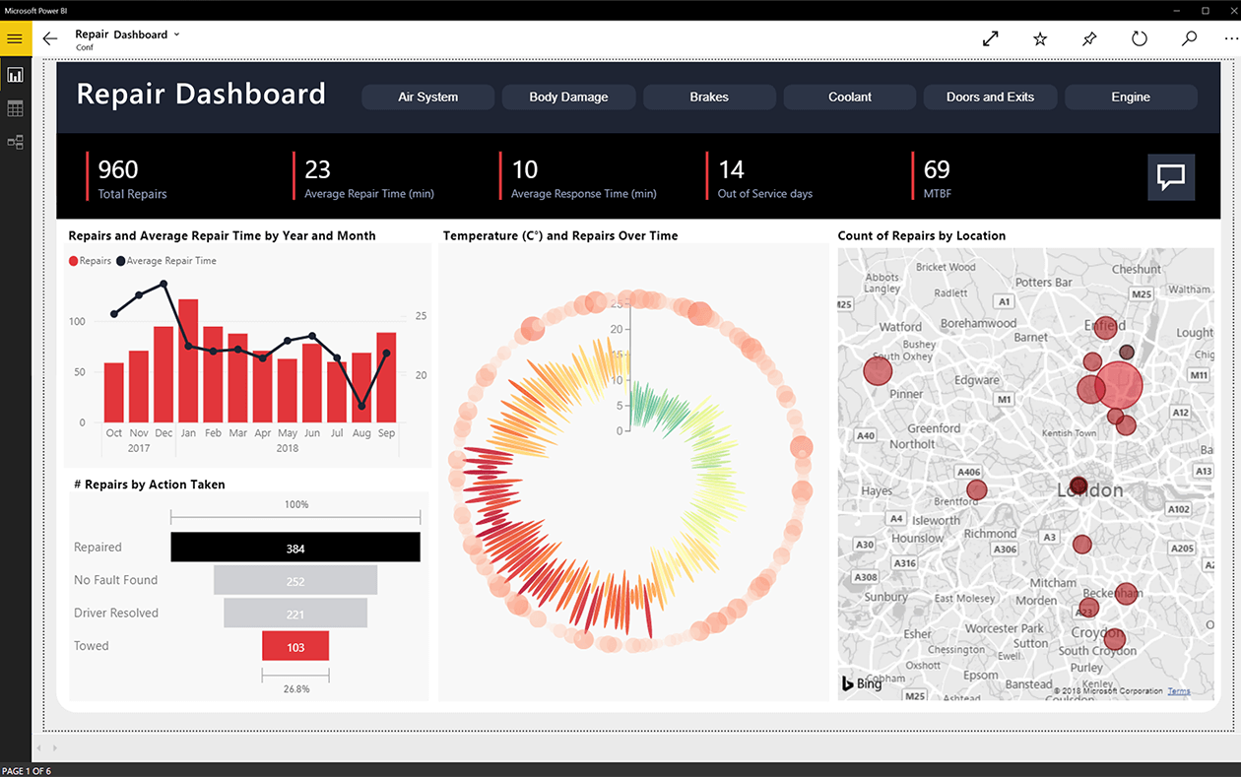

**FIG 5: Shows the Interface of Microsoft Power BI.**

**UiPath**

UiPath is an Application that is used as a platform for [robotic process automation](https://en.wikipedia.org/wiki/Robotic_process_automation) (RPA).Robotic process automation (or RPA) is an emerging form of [business process automation](https://en.wikipedia.org/wiki/Business_process_automation) technology based on the notion of metaphorical [software](https://en.wikipedia.org/wiki/Software) robots (bots) or [artificial intelligence](https://en.wikipedia.org/wiki/Artificial_intelligence) (AI) workers.

In traditional [workflow](https://en.wikipedia.org/wiki/Workflow) [automation](https://en.wikipedia.org/wiki/Automation) tools, a [software developer](https://en.wikipedia.org/wiki/Software_developer) produces a list of actions to automate a task and interface to the back-end system using internal [application programming interfaces](https://en.wikipedia.org/wiki/Application_programming_interfaces) (APIs) or dedicated [scripting language](https://en.wikipedia.org/wiki/Scripting_language). In contrast, RPA systems develop the action list by watching the user perform that task in the application's [graphical user interface](https://en.wikipedia.org/wiki/Graphical_user_interface) (GUI), and then perform the automation by repeating those tasks directly in the GUI. This can lower the barrier to use of automation in products that might not otherwise feature APIs for this purpose.

I attended a training on UIPath, I learnt how to use UIPath to automate basic tasks. I also had the opportunity to observe and learn from a proficient user of UIPath, a graduate Intern at chevron, Peter Ugah.

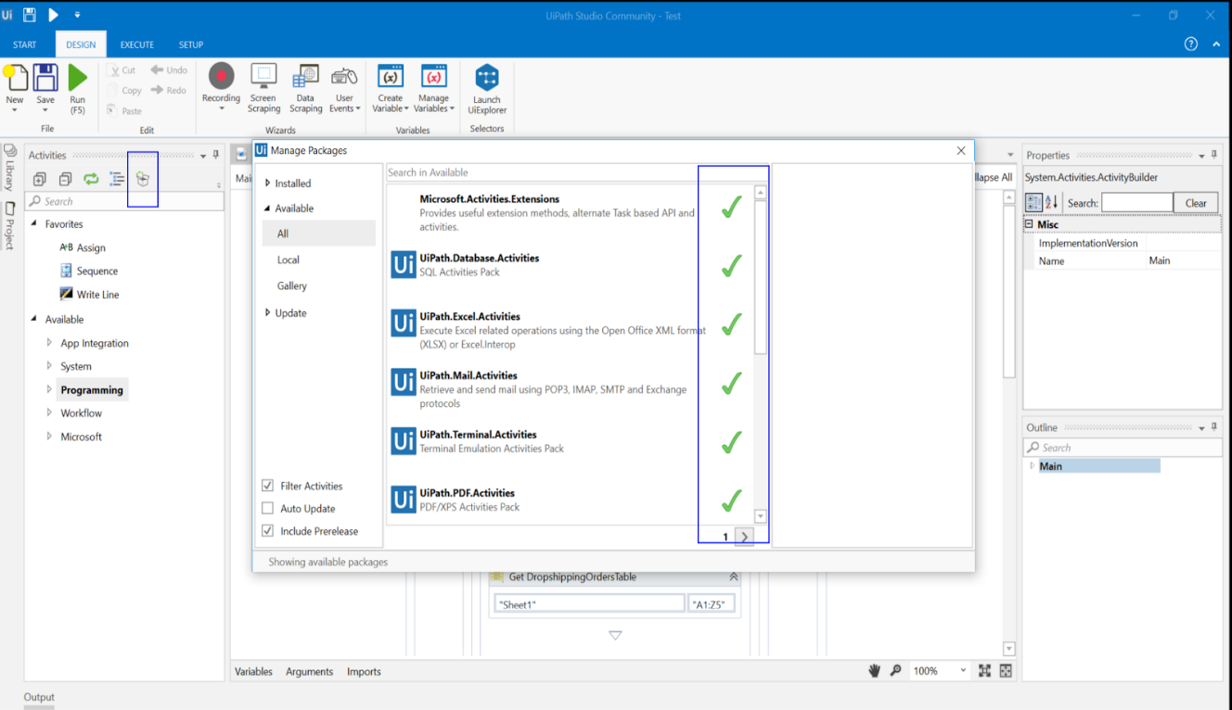

**FIG 6: Shows the Interface of UIPath.**

**Microsoft SharePoint**

SharePoint is a web-based collaborative platform that integrates with [Microsoft Office](https://en.wikipedia.org/wiki/Microsoft_Office). Launched in 2001, SharePoint is primarily sold as a document management and storage system, but the product is highly configurable and usage varies substantially among organizations.

In Chevron Nigeria Limited (CNL), SharePoint is used as a collaboration tool to promote teamwork cause of its many features such as version control and Simultaneous read/write access of documents to team members, it is also used sometimes as a document repository. I attended a 3-Days Training on SharePoint called “SharePoint Online for Administrators” organized by Chevron with facilitators from Digital Dialogue Limited. I received a certificate for completing this training.

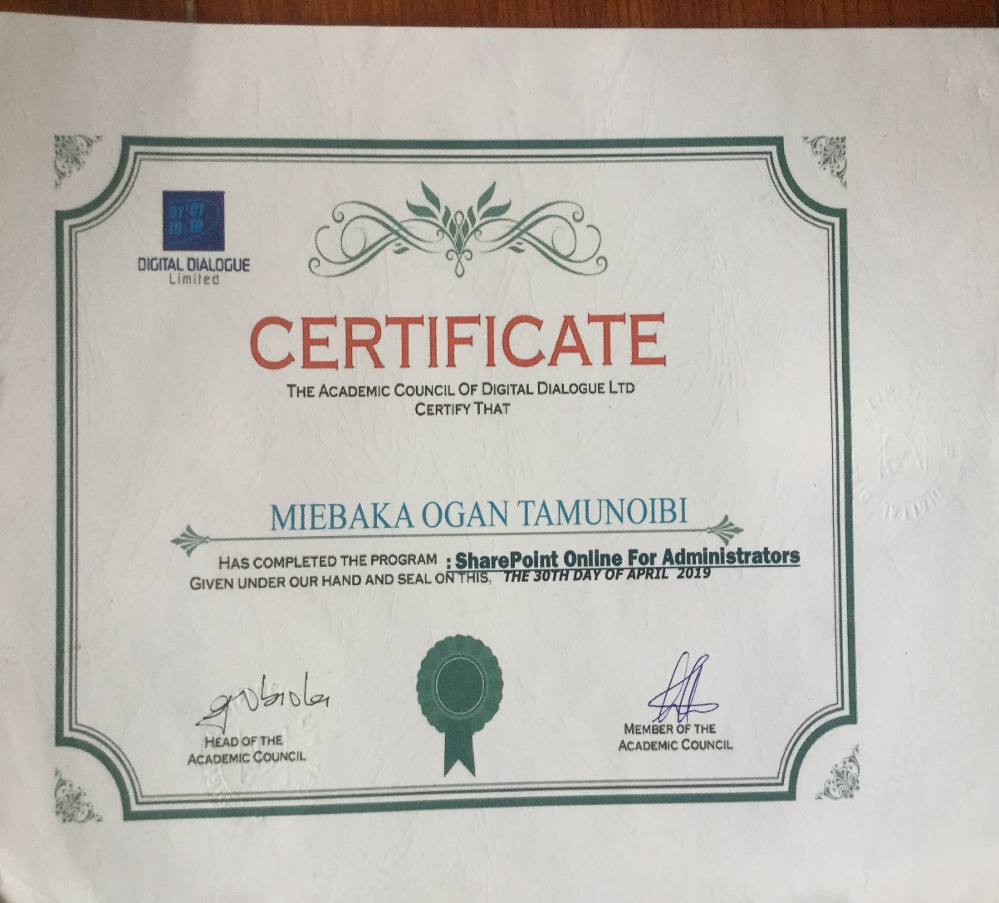

**FIG 7: Shows Recieved Certificate on Completion of SharePoint Training.**

I applied the knowledge I gained from this training in designing some SharePoint and I also provided assistance in creating a Document repository for the HR Department during my rotation with the Information Management (IM) Operation.

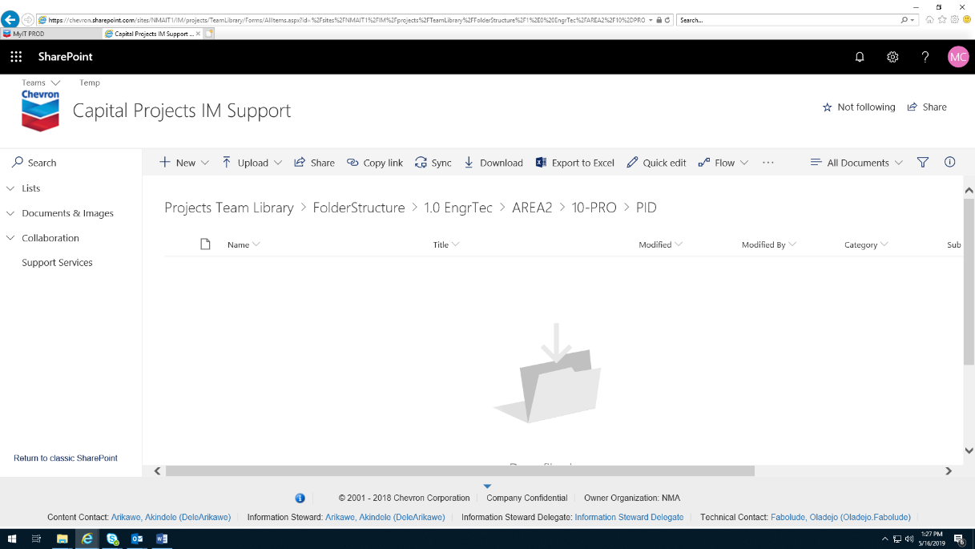

**FIG 8: Shows a SharePoint Page.**

**eB Information Manager**

eB Information Manager is the foundation of Bentley’s AssetWise system of servers and services. It helps you control information and manage change throughout the asset lifecycle, ensuring the delivery of accurate, trusted information to operations and maintenance teams — wherever and whenever it is needed. eB uniquely integrates configuration and change management best practices to deliver asset information management services throughout the infrastructure asset lifecycle.

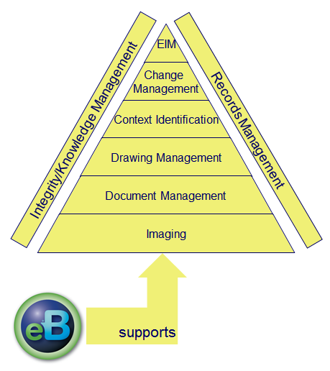

**FIG 9: Services provided by eB Information Manager.**

Key Benefits

* Improves operational efficiency
* Improves quality and safety
* Reduces costs
* Enforces information governance polices to meet regulatory compliance
* Minimizes business risk
* Helps capture and maintain institutional knowledge

This Software has intensive application in my primary work unit to handle the massive number of documents being created and exchanged in cycle of Major Capital Projects. I was mentored in the use of the software by my industry supervisor in the person of Mr. Onyekachi Malokwu and an expert in the Software, Mrs. Titilayo Makinde. I also used this software to perform some of my tasks, I shared more about this in my work done section.

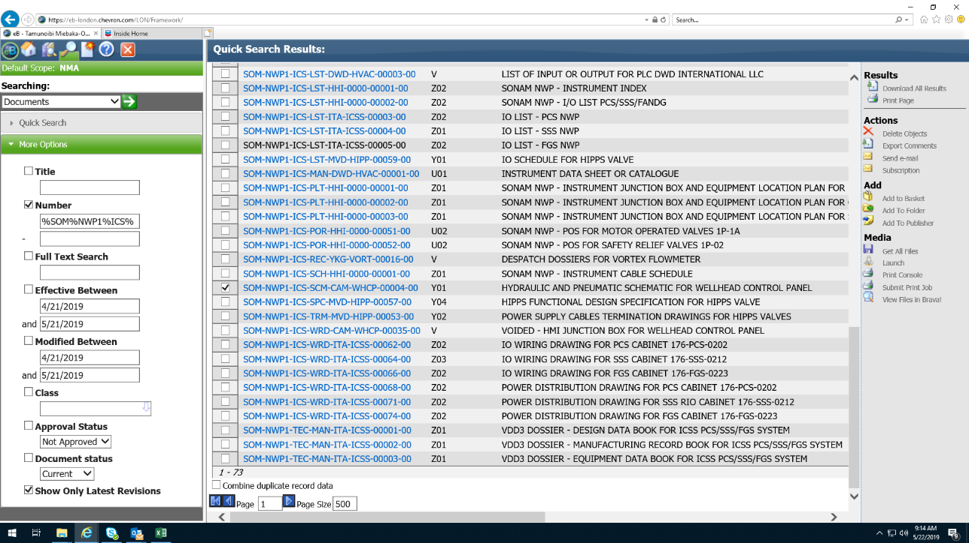

**FIG 10: Shows an eB Information Manager Interface.**

**Microsoft Excel**

Microsoft Excel is a software program produced by Microsoft that allows users to organize, format and calculate data with formulas using a spreadsheet system. This software is part of the Microsoft Office suite and is compatible with other applications in the Office suite.

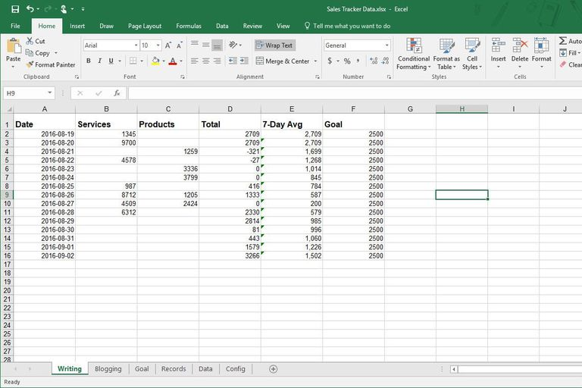

**FIG 11: Shows a Microsoft Excel Interface.**

**Microsoft Teams**

Microsoft Teams is a unified communications platform that combines persistent workplace chat, video meetings, file storage (including collaboration on files), and application integration.

This software was mainly used for team building exercises and passing information across the team.

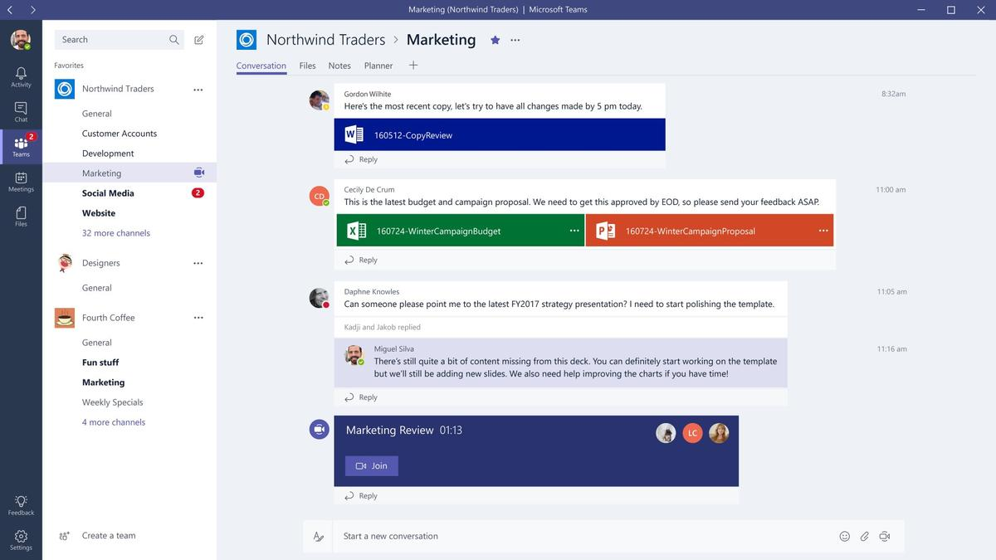

**FIG 12: Shows a Microsoft Teams Interface.**

Some other software tools I worked with were:

**Skype for Business** is an [instant messaging](https://en.wikipedia.org/wiki/Instant_messaging) (IM) [enterprise software](https://en.wikipedia.org/wiki/Enterprise_software) used with [Skype for Business Server](https://en.wikipedia.org/wiki/Skype_for_Business_Server) or with Skype for Business Online. I used this software for fast communication with team mates.

**Microsoft OneDrive** is a file hosting service and synchronization service operated by Microsoft as part of its web version of Office. I used this software for storing company files securely as well as sharing files.

**Microsoft OneNote** is a computer program and mobile program for free-form information gathering and multi-user collaboration. It gathers users' notes, drawings, screen clippings and audio commentaries. Notes can be shared with other OneNote users over the Internet or a network. I used this software for creating my weekly reports to my team and my Industry Supervisor.

**Microsoft PowerApps** is an initiative by Microsoft that allows developers and nontechnical users to build mobile applications from selectable templates. Users can share business apps on iOS, Android and Windows devices. I did not directly work with this software but I learnt by observing my fellow interns who did.

**DEGAUSSER**

It is a machine used to eliminate data stored on computer and laptop hard drives, floppy disks and magnetic tape, by randomly changing the alignment of magnetic domains on the medium.

Degaussing magnetic media leaves the domains in random patterns with no preference to orientation, thereby rendering previous data unrecoverable. A degausser is therefore used to completely erase all audio, video and data signals from magnetic storage media.

This process is effective in a range of industries including video, audio, computer, broadcast and data security.

**BENEFITS OF USING A DEGAUSSER**

* Assurance that all sensitive data has been erased permanently
* Disposes classified media quickly, safely and in-house
* Improvement in the quality of output
* Sizeable savings in operating costs
* Meets the NSA and CESG requirements for sanitization of classified information

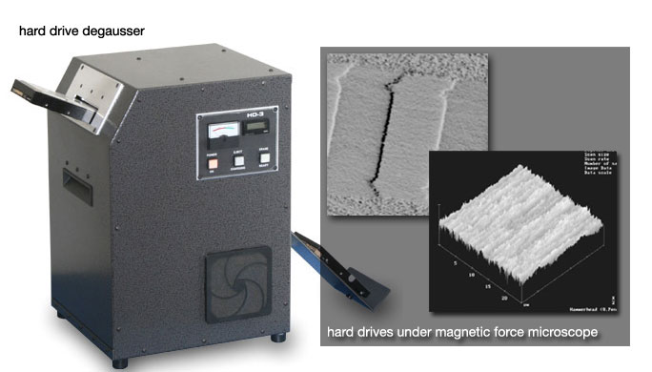

**FIG 13:A Degaussing Device.**

### Quality of Supervision

The quality of supervision I received during my internship at Chevron Nigeria Limited(CNL) was excellent. In accordance to Chevron’s internship policy, there is a mentorship system in place for interns. Based on this system, on my first day of resumption I was assigned a mentor (my company-based Supervisor) in person of Mr.Onyekachi Malokwu. I received outstanding guidance from him, as much as his duty as a staff allowed him he was available but more importantly he was able to refer me to other chevron personnel to enable me learn the same thing from different perspectives and also observe different job roles and see the full picture behind the team effort. I learnt a lot about working in a team. I was able to observe how in a huge company like chevron, everyone’s job is interlinked, having work performed by one employee as input to another job role.

My Mentor also designed a work plan for me which I completed within my internship duration. Below is

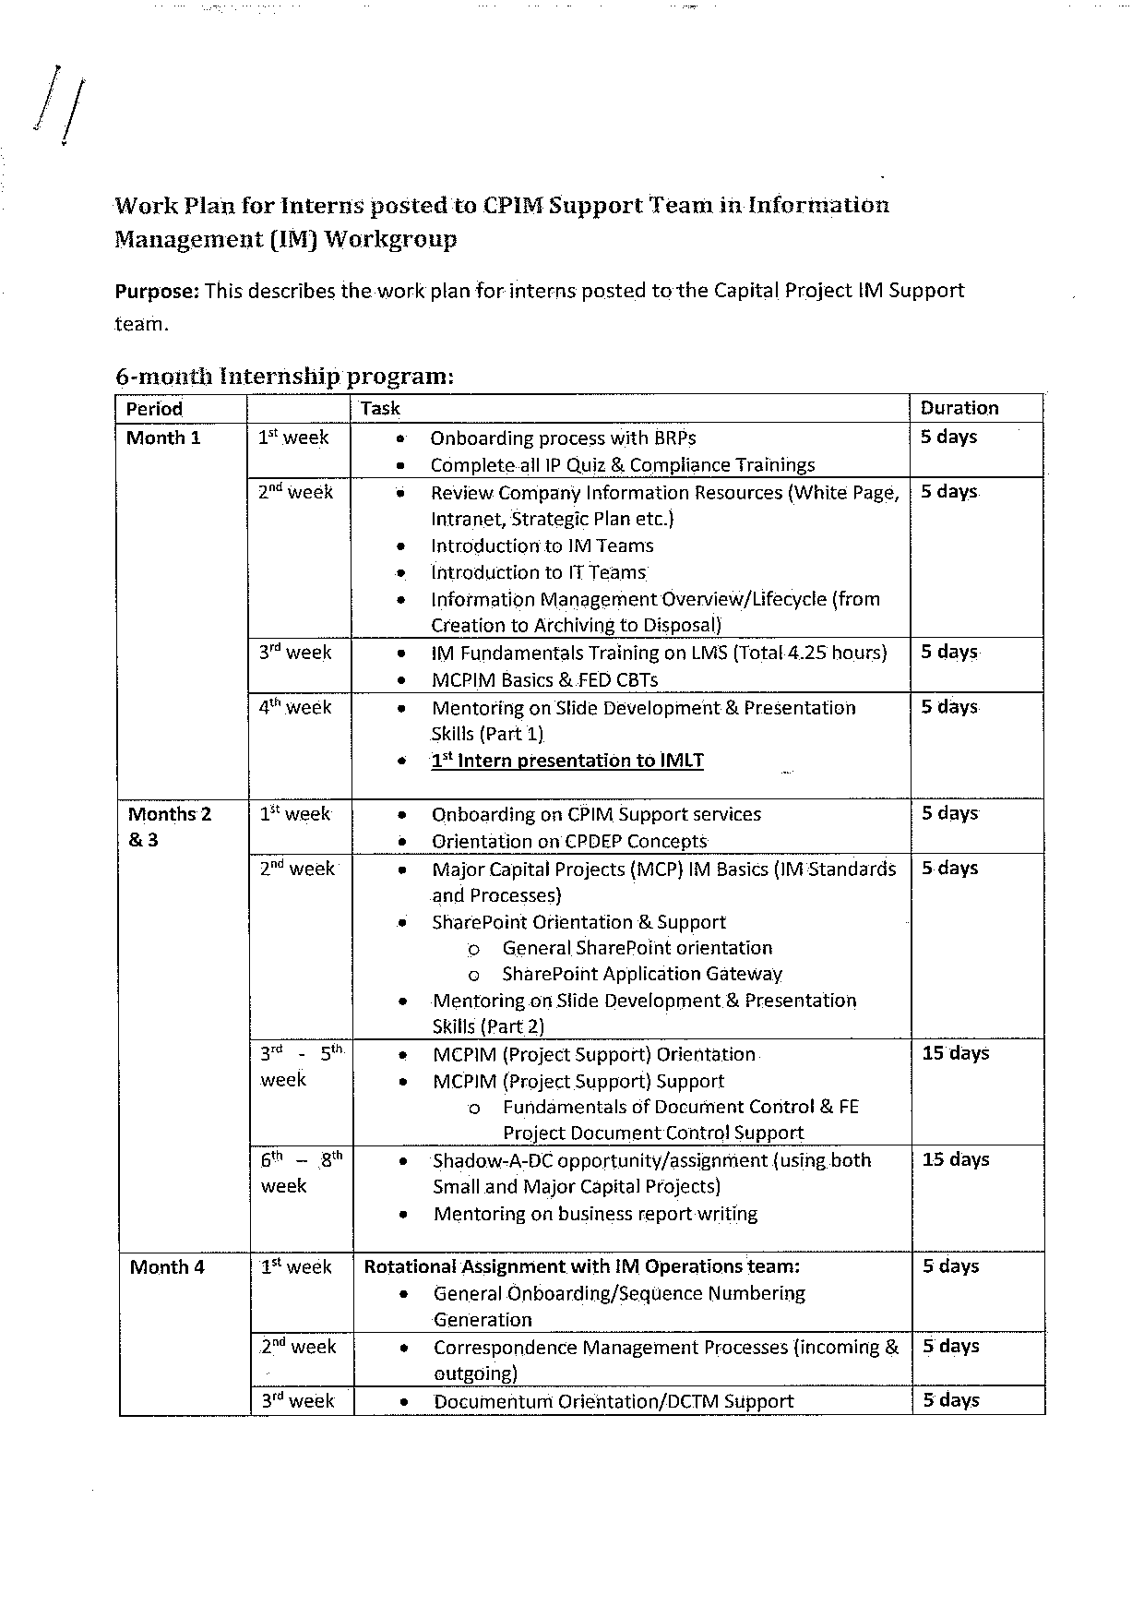

**FIG 14: My Internship WorkPlan (Page 1 of 3)**

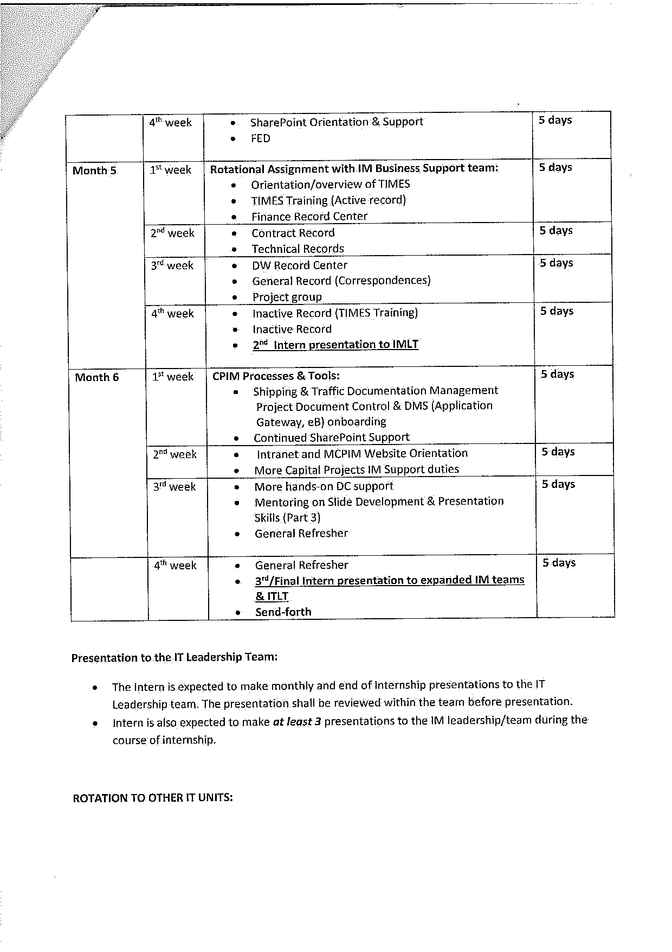

**FIG 15: My Internship WorkPlan (Page 2 of 3)**

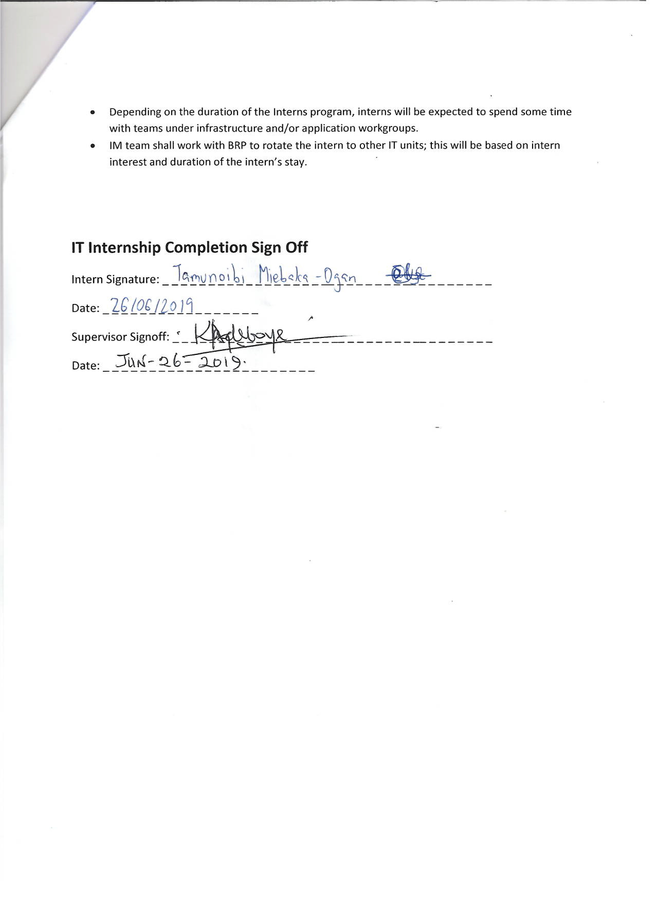

**FIG 16: My Internship WorkPlan (Page 3 of 3)**

### Work Done & Knowledge Gained

Here are the tasks I carried out in various units and the knowlege I gained while performing them:

**Major Capital Project Information Management Unit Tasks**

**Document Control Tasks:**

Within the Capital Projects Information Management Support(MCPIMS) Unit I was assigned to, the role of a document control is to provide support to ongoing Capital projects by handling the exchange of documents between chevron internal engineers and contractors that are hired to execute such projects, while ensuring the integrity of these documents by enforcing chevron standards for document control as specified in the Capital Projects Information Management Support(MCPIMS) Guidelines.

Here are some tasks I carried out under this unit:

* + Training on Information Management Overview/Lifecycle (from Creation to Archiving to Disposal).
  + Information Management (IM) Fundamentals Training on LMS (Total 4.25 hours).
  + Training on Fundamentals of Document Control & FE Project Document Control Support (On boarding on CPIM Support services).
  + Shadow-A-DC assignment (using both Small and Major Capital Projects)
  + Transmittal handling for outbound and inbound project documents.
  + Creation of Project-Specific Document Numbering guidelines from available templates to enable external document controllers comply to chevron standards.
  + Document Review Report Dashboard Verification. Identifying documents yet to be received.
  + Project Document Control & Document Management System(DMS)(3PC, eB) on boarding.
  + Frequent Update of Transmittal Log for some CPIM projects.
  + Intranet and MCPIM Website Orientation.
  + Restructuring of Funiwa LACT Rehabilitation Project Folder and Document Nomenclature to ensure compliance with the Chevron Major Capital Information Management (MCPIM) Taxonomy.
  + Transmittal handling using the Enterprise Bridge (eB) Electronic Document Management System software by instruction.
  + Provided support in MDR (Master Document Register) Creation for Funiwa LACT Rehabilitation Project.
  + Retrieval of Documents from eBentley (eB) Document Management System for SONAM Project for upload into the Global Documentum System.
  + I performed a survey with the sole purpose of arriving at a uniform Project (Engineering/Technical) folder structure within the CPIM Team.
  + Creation of Project Deliverable Schedule (PDS) for Several Projects.

**Experience Gained from Document Control Task**

**Project Management:** One of the skills I built through observation and in the performance of the role of Document Controller is project management. A vital lesson I learnt is the need for a thoroughly designed project Schedule and the channelling of all resources to ensure that the project is executed in alignment with the Project Schedule.

Another task that I carried out in relation to project management was: I created a Graphical (Chart) Representation of the project schedule for the “Archive Document Shredding Project” to monitor execution progress at a glance.

**Information Management:** Information management refers to all the processes and tools involved in handling Information (especially documents) throughout its life cycle. Under this I learnt the following:

* Version controlling of documents.
* Importance of avoiding duplicates and ensuring all reference to a file points to the same document, so no information is lost.
* I learnt about some information security techniques
* I learnt how to manage Concurrent engineering documents. Concurrent engineering documents simply refers to drawings documents being modified simultaneously/concurrently by engineers from different disciplines.
* I learnt about the relevance of a standard naming system for company documents to ensure proper identification and retrieval of company documents.

**Team Building and Team Management:** Throughout the duration of my Internship I attended weekly meetings on Mondays, where team members share/report their work activities performed during the previous week and then share challenges faced and solutions around such challenges.

During my internship I also experienced a strike in the organisation and I spoke to the Information Management Manager on the effect of strike on ongoing projects and ways to go around it and he was very happy to enlighten me on this.

**IM Operations Tasks**

**SharePoint Administration (Developer) Tasks:**

* + SharePoint Orientation & Support.
  + Participated in a 3-day SharePoint Administration Training.
  + I designed the Agbami Operations Team TVO page on SharePoint based on specifications.
  + Worked with IM Operations SharePoint team to develop a document repository for HR.

**Experience Gained from SharePoint Admin Tasks**

**SharePoint Site Management:** I learnt some basics on how to manage SharePoint sites with respect. I learnt the following:

* Handling Access issues whereby authorized users are not able to their data or sites on SharePoint.
* I learnt how to create Work Flows to automate Business processes on SharePoint.

**SharePoint Site Design:** With Supervision I was able to redesign an existing SharePoint page on the chevron Network. Below is a Screenshot of the page:

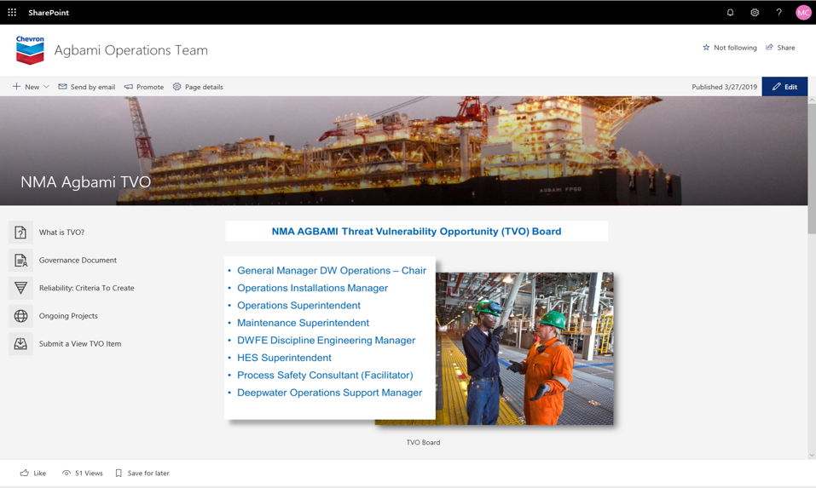

**FIG 17: Design of Agbami Operations Team Page (Page 1 of 2).**

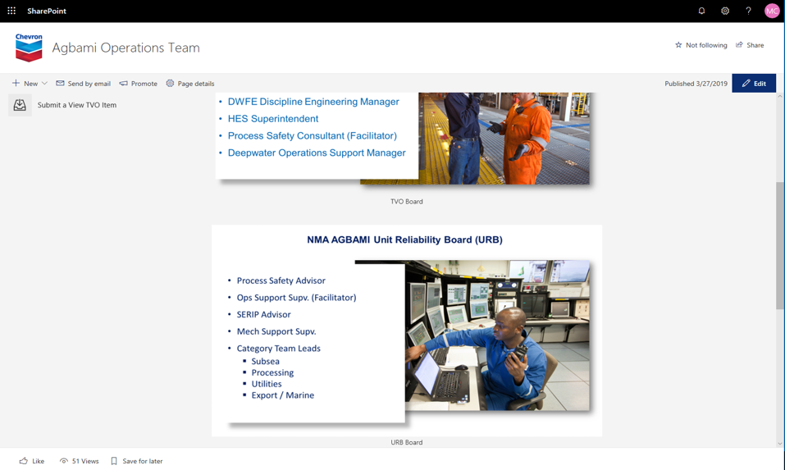

**FIG 18: Design of Agbami Operations Team Page (Page 2 of 2)**

**Information Management Business Services (IMBS) Unit Tasks**

The IM Business services units provides information management services to other chevron departments, most especially the Finance Records and Contracts records department. I learnt how to handling finance records and contract records. Below are the tasks I performed in this unit:

* + The Information Management Enterprise System (TIMES) Training (Active & Inactive records).
  + General Onboarding/Sequence Numbering Generation.
  + Correspondence Management Processes (incoming & outgoing).
  + Documentum Orientation/DCTM Support.
  + Digitization of Company Correspondence(letters) and indexing in TIMES (The Information Management Enterprise System).
  + Company records management (Engineering & Technical, Financial, Contract (legal) records).

**Knowledge Gained from the (IMBS) Unit**

In this unit I further applied skills with respect to information management. The knowledge I gained from this unit was how to manage physical records. Due to government specifications certain legal documents have to be kept in hardcopy and signed physically with a pen. I learnt how to store and retrieve physical contract records according to the chevron records system.

**Data Science Unit Tasks**

The final unit I worked with was the Data Science Unit. Below are the tasks I performed in this unit:

* + Data cleaning/preparation of mail correspondence documents data before analysis.
  + I applied excel formulas to analyze mail correspondence documents while extracting time duration for each document processing stage.
  + Power Bi for Data Visualization training.

**Knowledge Gained from Data Science Tasks**

**Application of Excel Formulas:** I Learnt how to use Microsoft excel to manipulate data and perform basic calculations and data analysis

**Power BI for Data Visualization:** I Participated in an all-day class on Power Bi as a tool for data visualization, analysis & report generation in business routine procedures.

**Knowledge Gained from Trainings**

During my internship I registered for several Chevron organized trainings, some were handled by facilitators while some where computer-based trainings. I also received certification for some trainings. Below I some trainings I participated in:

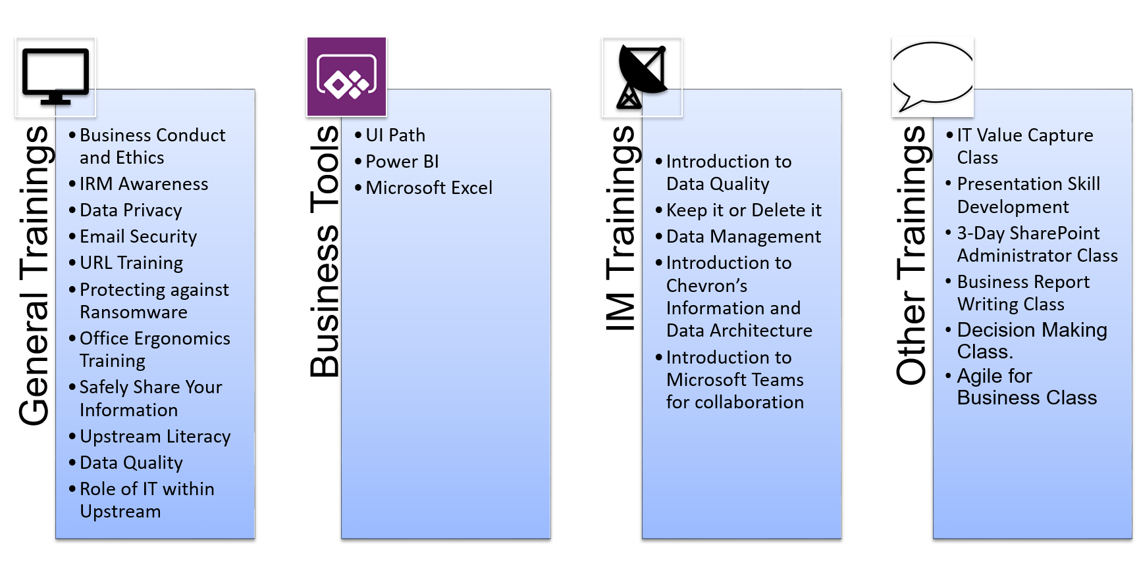

**FIG 19: My Completed Trainings**

**Some Certificates recieved from trainings**

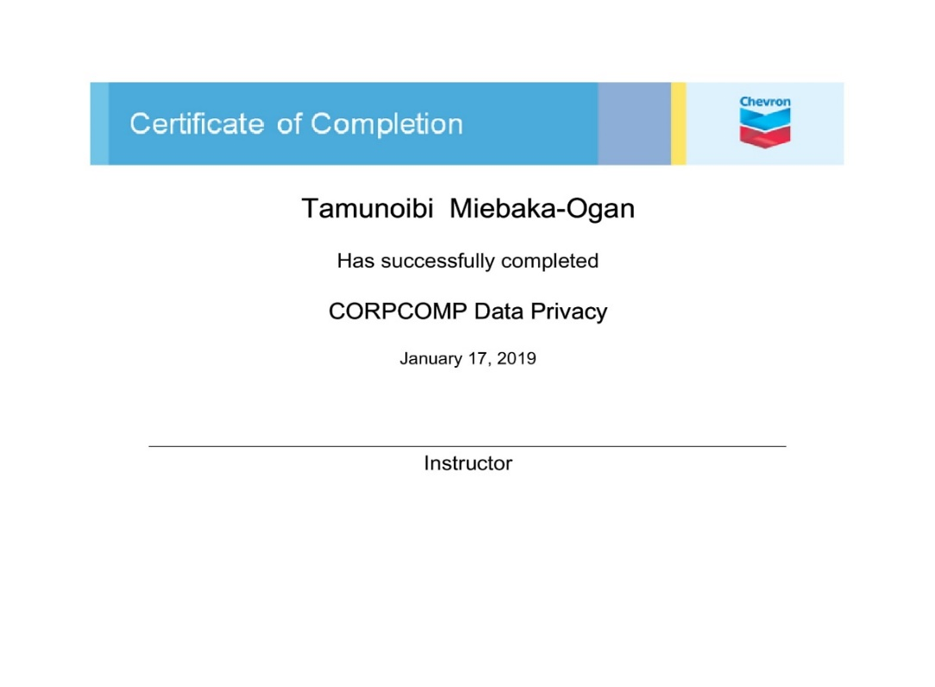

**FIG 20: Data Privacy Training Certificate**

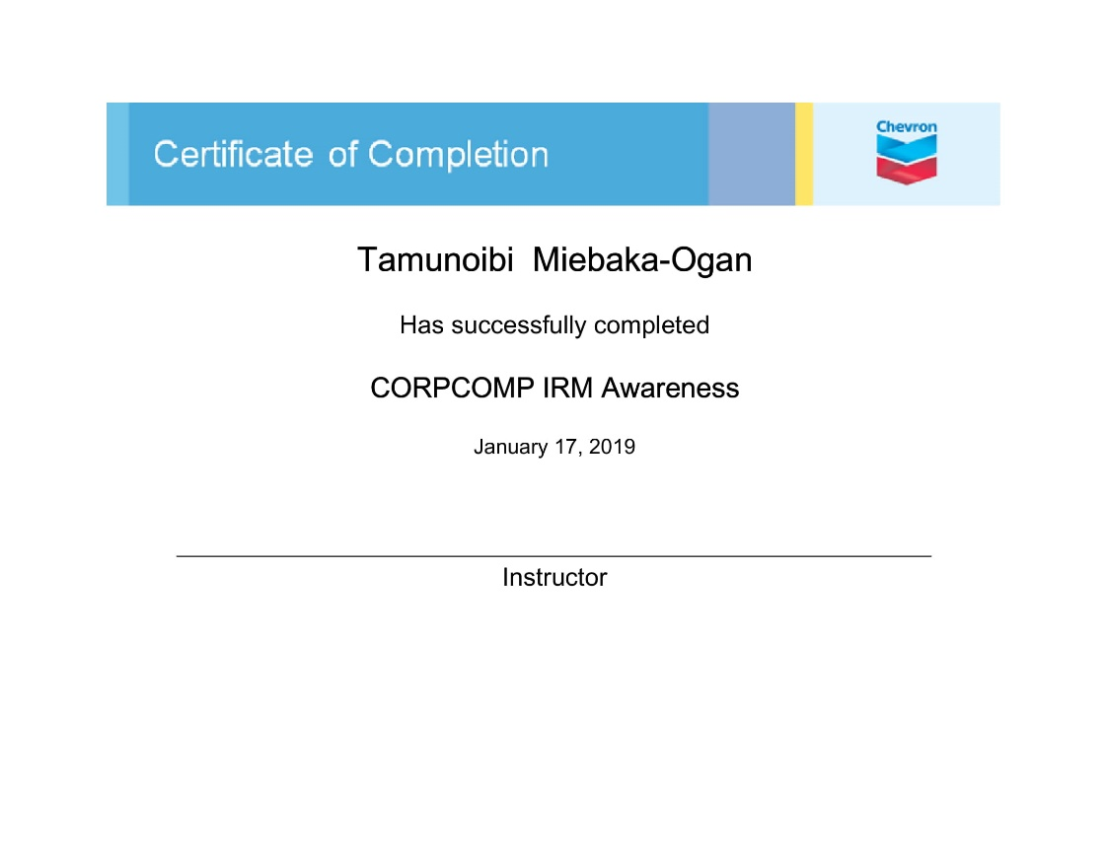

**FIG 21: Information Risk Management Training Certificate.**

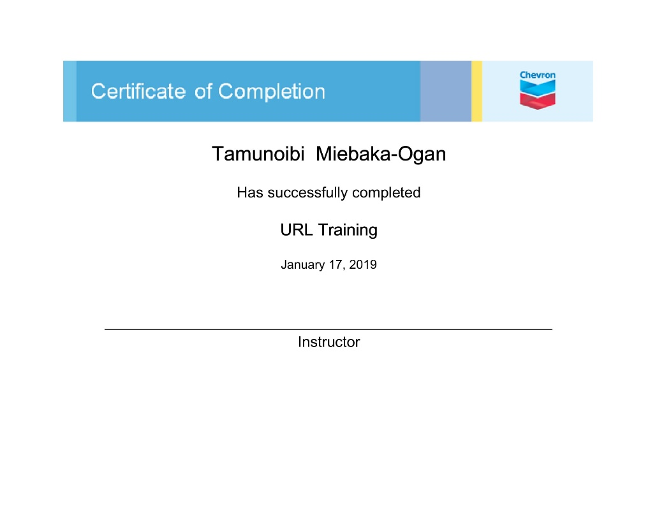

**FIG 22: Uniform Resource Locator Training Certificate.**

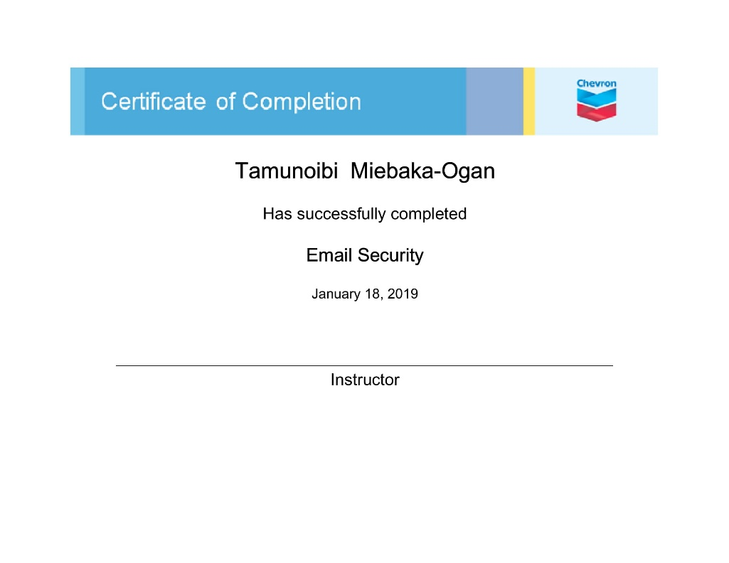

**FIG 23: Email Security Training Certificate**

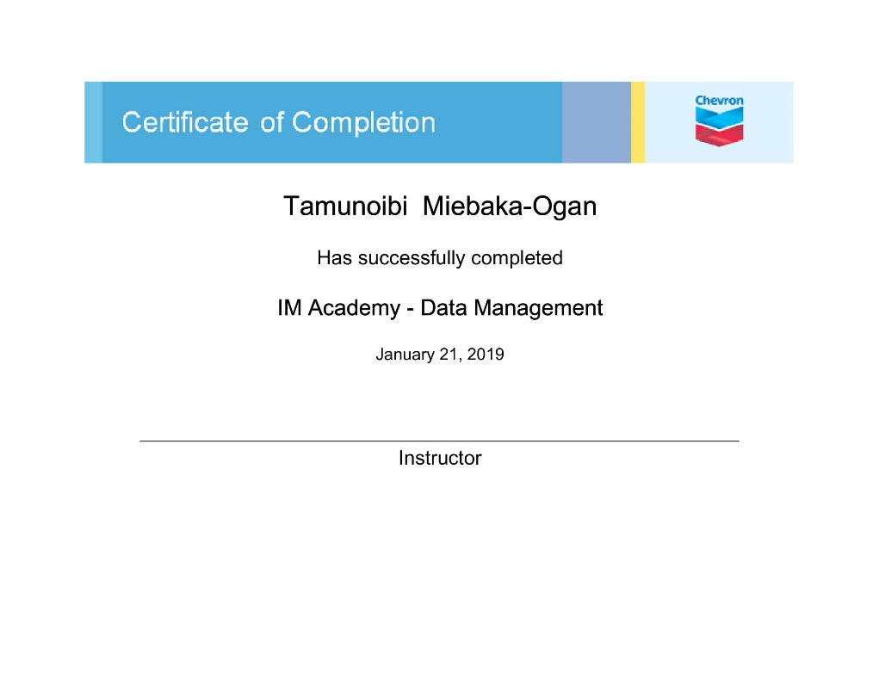

**FIG 24: Data Management Training Certificate**

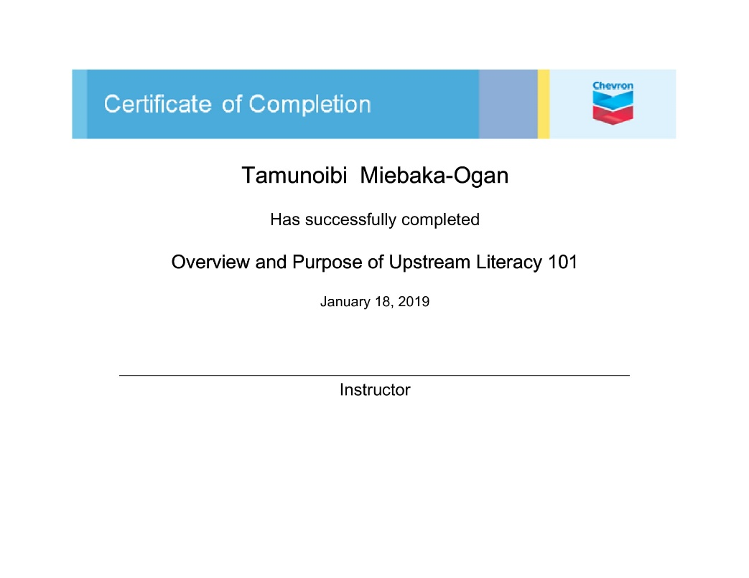

**FIG 25: Upstream Literacy Training Certificate**

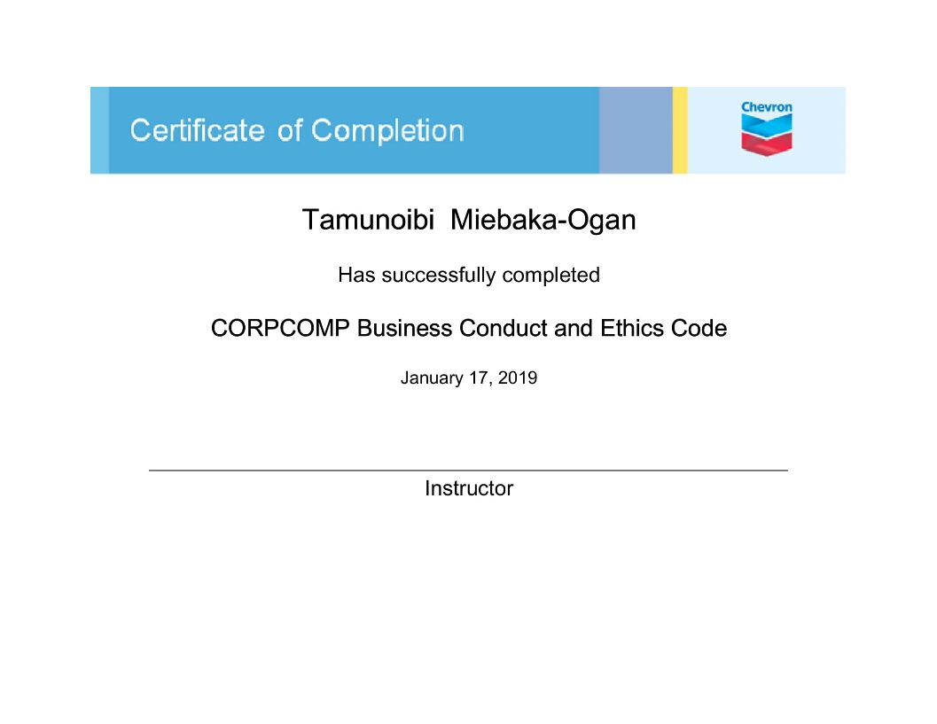

**FIG 26: Business Conduct & Ethics Code Training Certificate**

**Knowledge Gained (Others)**

**Application of Information Technology in Business Procedures:** One thing I was curious to see was the role of IT in a company like chevron which isn’t Technology focused but rather technology driven in order to accomplish company Goals. Through several interactions with some of the chevron IT Leadership personnel I realized the best of technology is experienced when it isn’t just technology for the sake of technology but technology applied in order to solve business problems, to simplify business procedures in order to boost process efficiency and thus gain competitive advantage. Several times even before doing basic things like upgrading hardware, the IT Leadership must first weigh the advantage of this acquisition to the business process against the cost of acquisition.

**Public Speaking and Effective Communication:** During my internship I attended several training exercises on public speaking, presentation making and effective communication for team building. I learnt a lot from these and my ability to communicate ideas has greatly improved.

**Time Management:** I learnt about time management as a result of multiple tasks I was assigned, I learnt how to be effectively prioritize and ensure no crucial work lags behind by applying time management and task prioritization.

# CHAPTER THREE: APPLICATION OF KNOWLEDGE GAINED

Application of Knowledge Gained on:

### 3.1.1 Field of study and Educational career

From a general perspective, as a student of Computer Science I learnt how Information technology in terms of Information Management, Application Development, Information Security can be applied within an organization to drive business Goals, this is a crucial skill for someone in my field because it is paramount to learn how the solutions we develop in the classroom can be applied in real world situations to sponsor the growth of an organization by building efficient business procedures on foundation of innovative application of technology. Asides the above benefit, some other applications are:

* Information Management: Information management is a very crucial concept in computer science and the application of this concept is even more crucial. I learnt how to handle company information carefully and ensure that only authorized users have access to data.
* IT Value Communication: I learnt how to present IT value in terms of business value. This basically is the ability to express technical processes and concepts in terms of value and benefits to the business when communicating with stack holders and other business/profit concerned personnel.
* Career Opportunity: Due to the experience I gained from this internship I also have the opportunity to pursue a career in data management, project management, SharePoint administration and with more effort I could also pursue a career in data science.

### 3.1.2 The goals of the company of engagement

* Safety Culture: Chevron Nigeria Limited is an organization that is exceptionally aware of the security of lives and offices. One of its ongoing objectives is to accomplish zero extreme occurrences and fatalities in the year. I have taken in a great deal about security procedures and how to utilize safety instruments, so this would empower me to be of assistance in accomplishing the objective.
* Handling of Company Information: One of the Goals of Chevrons IT Department is to ensure that relevant information is always available to authorized users, from the experience I gained from SharePoint administration for access control, as well as through the use of eB Information Management Software, I helped contribute to this goal.

### 3.1.3 The larger society:

In our Nigerian Society there are a lot of problems that could be tackled by technological solutions, I believe that with my growing skills in programing, project management and information handling, I could provide solutions to some of these problems.

### 3.1.4 Practical Training with Theoretical Knowledge

From the experience I gained through my internship I was able to see reason for the value and emphasis placed by my lecturers on theoretical concepts in computer science because only with proper understanding of these can you efficiently apply such concepts. One of such concepts is the concept of data specification and proper data modelling before creating a database. During my internship I observed how efficient the chevron databases and applications built in these databases as a result of proper specification and modelling.

Also I understood the need for a structured naming system for naming documents which helped to ensure that any documents can be retrieved by any authorized document handler with adequate knowledge of the naming system in place. For example, I was able to retrieve so missing documents for a project that had started several years before my internship simple by understanding the chevron naming taxonomy.

Based on this I fully support and applaud the emphasis placed on theoretical knowledge in our educational institutions today.

### 3.1.5 Culture and Culture Shock Experiences

Chevron Nigeria Limited is an oil company which places a lot of importance on **Safety and Security.** One of its major goals which was set recently is to ***Achieve zero severe incidents or facilities per year.*** Due to this, meetings are held to emphasize the importance of safety to workers every month. Prior to any official meeting, there is a 5 minutes talk on safety which could be specific on actions in the field, or office. Also, there are hazard hunts observed periodically to identify potential incident scenarios. After my first month in chevron I developed a healthy sense of vulnerability that made me safety conscious even at home.

In terms of security, in Chevron the IT department is very passionate about information security, interns where instructed to always shred sensitive documents after use and to never leave their work systems unlocked while stepping away. After a couple of mistakes, I imbibed all this and adapted to the culture of the environment.

### 3.2 Challenges Faced

**Company Terminology**: For the first two weeks of my internship I could barely understand what was said in our weekly meetings because of some company terms (e.g. acronyms) and engineering terms, none of my team mates were engineers but because we worked in a company that deals with a lot of engineering details to manage such information it’s important to have at least a surface understanding of such concepts. I intentionally began to ask questions when possible and consult the internet for others and after about 2months of my internship I could both understand and communicate using the relevant terms.

**Access Restriction to some Software:** As intern I wasn’t granted to some software that I had interest in learning, but I understand that it’s important to protect company information. After making several requests to my company Supervisor I was able to get a restricted access to some of these software and I am grateful for that.

### 3.3 Challenges faced by the Company

**Lack of a Standard Project Folder Structure:** Within my team, the Major Capital Projects Information Management Support (MCPIMS) we faced a situation whereby different document controllers had different project folder structures this wasn’t harmful previously because all the processes on the documents were performed manually but with the desire to be more efficient by automating some of these procedures, this challenge surfaced.

To solve this problem, I performed a survey with the sole purpose of arriving at a uniform Project folder structure within the CPIM Team. After getting feedback from my team mates I developed a structure which I proposed as the new standard, after some deliberations and modifications, this structure was accepted and adopted in across the team.

### 3.4 Project Identified by the Student

After familiarizing myself with the routine processes performed by my team I highlighted some parts of the process that would be better automated due to its lack of complexity but heavy repetition. Since I didn’t have the skill set to handle this project, it was handled by a more qualified team mate. However, I contributed to this project by coming up with the uniform folder structure which I previously mentioned.

# CHAPTER FOUR: CONCLUSION

The main aim of SIWES is to collaborate practical and industrial experience with the theoretical knowledge that had been taught in schools to optimize learning. This training program has paid off in no small way as great skills were learned throughout the different activities and tasks engaged in, during the industrial training period. The SIWES experience has helped me greatly to reconcile some of the theories learnt from my books with pure industrial practical skills, I was able to meet and interact with some great minds hereby enlarging my network and setting me on a good career path. I am extremely grateful for this SIWES Internship Experience I believe that this experience I have gained has made me more prepared for a career in Information Technology.

My understanding of the outside world (i.e. labor market, Work force) has been buttressed and things to expect when in certain circumstances after graduation.

Furthermore, I would like to applaud Chevron Nigeria Limited for the opportunity to work with them. It has been a most wonderful experience and I want to thank them for their belief in me and support throughout my industrial training.

REFERENCES

* <http://www.wikipedia.org/>